Adaptive Agricultural Multi-Agent Simulation under Altitude Constraints:
A Prototype for Modeling Crop Adaptation, Resource Pressure, and Reinforcement-Based Decision Making
Alejandro Martinez

Abstract
This project presents a research-oriented prototype for the simulation of adaptive agricultural systems through reinforcement learning, procedural seed evolution, and ecological constraints. The project explores how artificial agents representing early agricultural communities may learn to survive across different altitude zones by balancing cultivation, movement, resource consumption, and population growth.
The system combines a stochastic seed adaptation model with a reinforcement learning framework in which agents develop environmental memory based on previous cultivation outcomes. Each crop variety evolves according to environmental influence and probabilistic mutation, while agents attempt to maximize food efficiency under conditions of scarcity and uncertainty.
Unlike traditional optimization systems focused solely on productivity, this prototype emphasizes adaptive behavior under limited information. The agents do not initially possess knowledge of the environment and progressively construct localized memories regarding crop efficiency at different altitudes. Resource pressure is represented through a tension model linked to food reserves and population requirements, influencing exploration and decision-making.
The current implementation demonstrates the emergence of non-trivial behaviors such as localized settlement patterns, repeated exploitation of productive ecological zones, risk-sensitive movement, and partial environmental specialization of crop varieties. The project is intended as an exploratory foundation for future research in adaptive multi-agent systems, ecological simulation, and reinforcement learning under environmental uncertainty.

Content
Abstract 1
1. Introduction 3
2. Research Objective 3
3. General System Overview 4
3.1 Environment 4
3.2 Crop Varieties and Seeds 5
3.3 Agent Memory 6
3.4 Reinforcement-Based Decision System 6
4. Current Prototype State 6

1. Introduction
Human agricultural development has historically depended on the capacity to adapt crops and survival strategies to highly variable environmental conditions. In mountainous regions such as the Andes, ecological diversity across altitude levels forced agricultural communities to continuously experiment with cultivation techniques, crop selection, and territorial movement.
This project explores whether similar adaptive dynamics can emerge computationally through artificial agents operating under uncertainty. Instead of directly optimizing predefined agricultural outputs, the system attempts to model how communities may progressively construct knowledge about their environment through experience, failure, exploration, and resource pressure.
The simulation focuses on three central mechanisms:
- Procedural crop adaptation
- Environmental learning through memory
- Decision-making under food pressure
The environment is represented as a sequence of altitude zones in which different crop varieties may exhibit distinct levels of productivity. Artificial agents must decide whether to cultivate locally or move toward neighboring regions while balancing food reserves, population survival, and uncertainty regarding unknown territories.
The project combines ideas from:
- reinforcement learning,
- ecological simulation,
- stochastic adaptation systems,
- and multi-agent decision modeling.
Although the current implementation remains a prototype, it already exhibits emergent behaviors that suggest the possibility of modeling adaptive agricultural specialization through relatively simple local rules.

2. Research Objective
The primary objective of this project is to investigate whether adaptive agricultural behavior can emerge from the interaction between:
- environmental constraints,
- stochastic crop evolution,
- reinforcement-based learning,
- and resource pressure.
More specifically, the project attempts to answer the following research question:
Can artificial agents progressively learn efficient agricultural strategies across ecological altitude zones using only local experience and resource-driven decision-making?
The simulation does not attempt to reproduce exact historical agricultural systems. Instead, it serves as an experimental computational framework designed to study how adaptive behaviors may emerge from decentralized interactions between agents and dynamically evolving crops.

3. General System Overview
The system consists of four major components:

3.1 Environment
The environment is represented as a linear sequence of altitude zones. Each zone possesses a different height value that influences crop productivity.
Agents may perform two primary actions:
- cultivate
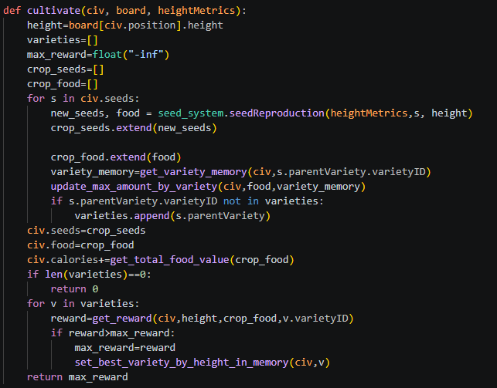
- move toward neighboring zones.
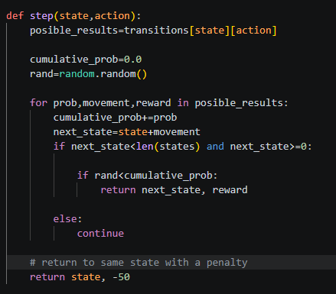
Movement introduces energetic and survival costs, while cultivation produces stochastic food rewards depending on crop adaptation.

3.2 Crop Varieties and Seeds
Each crop variety contains environmental preferences and adaptation characteristics.
Seeds inherit properties from parent varieties while also undergoing stochastic mutation influenced by:
- environmental pressure,
- altitude compatibility,
- probabilistic variation,
- and adaptive inheritance.
This produces evolving agricultural distributions over time.
For a reference, the following figure shows the evolution of the crops at different heights and height changes
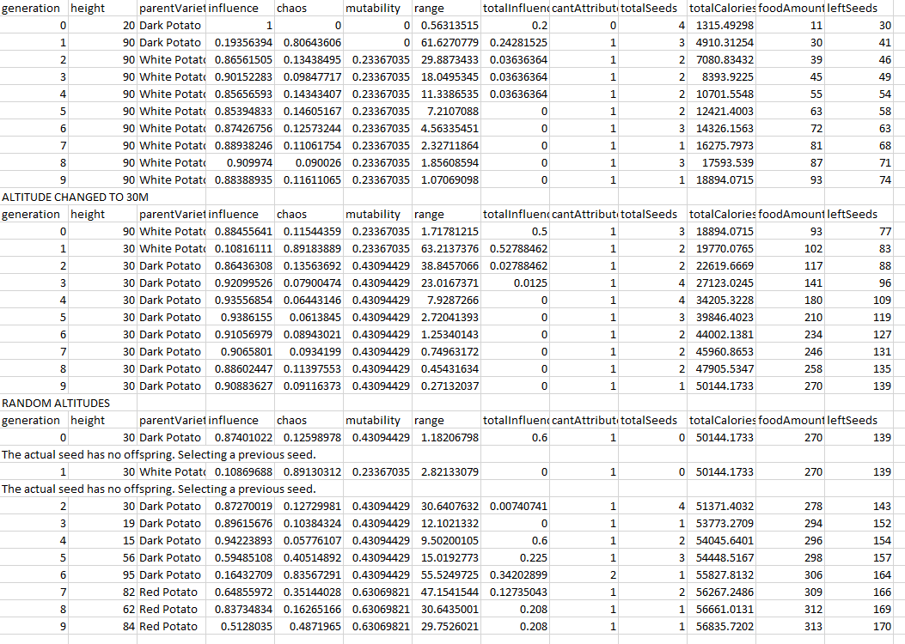

3.3 Agent Memory
Agents do not possess initial environmental knowledge.
Instead, they progressively construct localized memory structures storing information about:
- productive altitude zones,
- observed crop efficiency,
- previous cultivation outcomes,
- and successful environmental associations.
The memory system allows the agent to gradually transition from exploration toward exploitation.

3.4 Reinforcement-Based Decision System
Agents use a Q-learning-inspired framework to evaluate actions.
Decision-making is influenced by:
- expected food efficiency,
- environmental uncertainty,
- resource pressure,
- and movement costs.
A tension model linked to food reserves modifies exploration behavior dynamically.
When reserves are low, agents prioritize survival-oriented exploitation.
When reserves are high, exploratory behavior becomes more probable.

4. Current Prototype State
The current prototype already implements:
- stochastic seed evolution,
- environmental adaptation,
- reinforcement-based action selection,
- altitude-dependent cultivation,
- localized environmental memory,
- population-resource dynamics,
- and food-pressure-driven behavior.
Several emergent behaviors have been observed during experimentation:
- stabilization around productive altitude zones,
- oscillatory migration between neighboring regions,
- population collapse under resource imbalance,
- and adaptive preference formation for specific environmental conditions.
The current system remains highly experimental and continues to undergo balancing and architectural refinement. Future work will focus on improving:
- memory generalization,
- long-term planning,
- multi-agent cooperation,
- environmental realism,
- and statistical validation of emergent behaviors.

